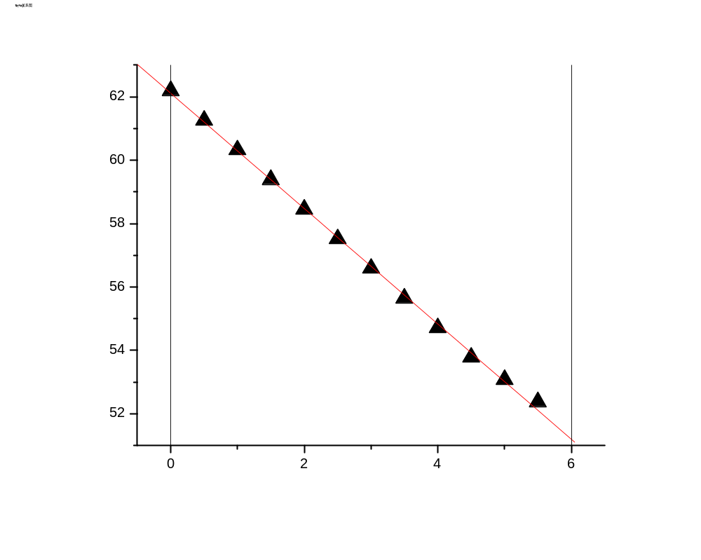
t(min) | 0 | 0.5 | 1 | 1.5 | 2 | 2.5 | 3 | 3.5 | 4 | 4.5 | 5 | 5.5
T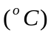 | 62.19 | 61.26 | 60.32 | 59.39 | 58.45 | 57.52 | 56.58 | 55.65 | 54.71 | 53.78 | 53.07 | 52.37

